

Web Technologies I

# TERM PROJECT

**INSTRUCTOR: Javeria Aamir**

**CLASS:** Winter 2021 (CSD 1113_1)

|  |
| --- |
| The term project brings together what has been covered in this course and what you have practiced in the exercises to create a website with at least four HTML5 pages.  • Total marks: 100 |

**Project Name: Foodies**

**Group Members Name:**

Ramandeep Kaur: C0789784

Sonia:C0804808

Suman Rani : C0796394

**2021© LAMBTON COLLEGE IN TORONTO**

* **Files in Folder:**

1. index.html
2. service.html
3. combo.html
4. feedback.html
5. dishes.html
6. css/style.css

* **Description:**

In this project, we have created a website for **food lovers of Indian ,Italian ,Greek cuisines and bevrages**. It is restaurant website to provide food online. The purpose of this website is to serve more clients through providing online service . The target audience of this website is people that love indian ,italian , greek foods and bevrages. This project has 5 main pages that together make a website .i.e home, our service, food categoriers,combo offers and feedback.We have used .jpg, .png .jfif and .jpeg graphics in this project. This project website is responsive. We have designed Wireframes views for desktop. Technology used for this website is HTML and CSS. Various HTML tags are used in this project along with external style sheets.

|  |  |
| --- | --- |
| **Section 1 – Planning Checklist** | **20 points** |

* **Answer the following questions**

* What is the Purpose of the Website?

**Answers:** This website provide online service for their customers who love to enjoy their food at their own places with comfort. By this website customers will get a good idea of of the overall atmosphere and food service of the restaurant.

* Who is the Target Audience?

**Answers:** *The target audience of this website all people that love our food services and like to enjoy it at their own places.*

* How many pages will be included in your website?0

**Answers:** *Our website contains 5 main pages*

* *Home page*
* *Our Service page*
* *Food Categories page*
* *Combo Offers page*
* *Feedback page*
* What graphics will you use on the website?

**Answers:** *We have used .jpg, .png .jfif and .jpeg graphics in our website.*

* What colors will you use on the website?

**Answers:**     

   

   

* What font styles will you use within the website?

**Answers:**  cursive

* What features will be displayed on the webpages?

**Answers:** we embedded

* google map for easy location finding
* provide easy navigation
* quick links to access webpages
* link to social media
* Visuals of services

|  |  |
| --- | --- |
| **Section 2 – Content Requirements** | **20 points** |
| * **Website sections:** * Home page * Header shows our logo and link of webpages * main shows visuals of food categories * *Footer shows contact info, quick links,google map with address and social links* * *Our service page* * *Shows services provided by our website* * *Food categories page* * *It shows different type of from indian ,Italian and Greek cuisines as well as Bevrages* * *Comb Offers page* * *It shows combination of 3 kinds of foods to buy on less rate as combo* * *Feedback* * *It provide a form to give us ratings based on our services and to give us some suggestions*   Use Semantic Wireframes to layout the features. |  |

* + Form
  + Nav
  + Header
  + Footer

|  |  |
| --- | --- |
| **Section 3 – Structure Requirements** | **20 points** |
| * Site Map (https://draw.io)  |  |  | | --- | --- | | |  | | --- | |  |      1. Products Listing Page.    1. Product Detail Page (Particular product). 2. Products Listing Page.    1. Product Detail Page (Particular product).    2. Product Detail Page (Particular product). 3. Product Detail Page (Particular product). 4. Products Listing Page.    1. Product Detail Page (Particular product). 5. Products Listing Page.    1. Product Detail Page (Particular product).    2. Product Detail Page (Particular product). 6. Product Detail Page (Particular product). 7. Products Listing Page.    1. Product Detail Page (Particular product). 8. Products Listing Page.    1. Product Detail Page (Particular product).    2. Product Detail Page (Particular product). 9. Product Detail Page (Particular product). 10. Products Listing Page.     1. Product Detail Page (Particular product). 11. Products Listing Page.     1. Product Detail Page (Particular product).     2. Product Detail Page (Particular product). 12. Product Detail Page (Particular product). 13. Products Listing Page.     1. Product Detail Page (Particular product). 14. Products Listing Page.     1. Product Detail Page (Particular product).     2. Product Detail Page (Particular product). 15. Product Detail Page (Particular product). |  * **Responsive design Wireframes** (https://wireframe.cc)   o Mobile  o Tablets  O Desktops   1. Home Page Layout:      1. Our Service Page Layout:      1. Food Categories Page Layout:      1. Combo Offers Page Layout:      1. Feedback Page Layout: |  |
| **Section 4 – HTML Requirements** | **20 points** |
| Web pages must contain:   * HTML5 semantic elements – Yes, we have used it in our website * Meta tags – Yes, we have used it in our website * Links – Yes, we have used it in our website * Images – Yes, we have used it in our website * Block and Inline content – Yes, we have used it in our website * Forms with basic validation – Yes, we have used it in our website * Tables – Yes, we have used it in our website * Headings – Yes, we have used it in our website * Paragraphs – Yes, we have used it in our website * Lists – Yes, we have used it in our website |  |
| **Section 5 – CSS Requirements** | **20 points** |
| * Fluid layout – Yes, we have used it in our website * Media queries – Yes, we have used it in our website * Flexible images – Yes, we have used it in our website * Box model – Yes, we have used it in our website |  |

* Text and font styling – Yes, we have used it in our website
* Forms styling – Yes, we have used it in our website
* **Validations:**

Home Page

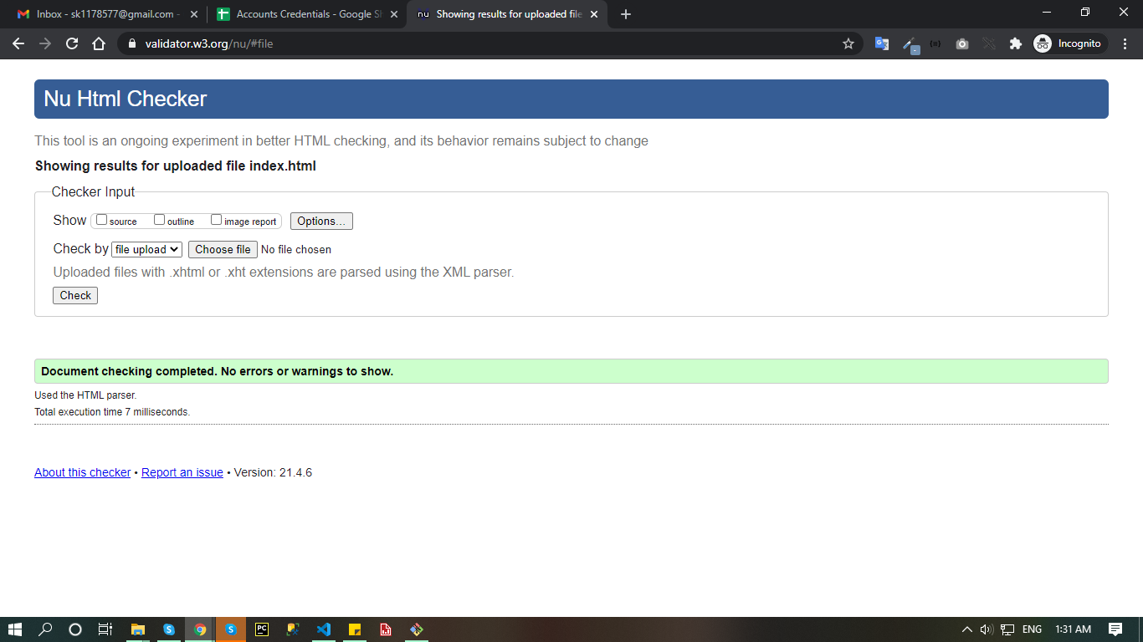

Our service

o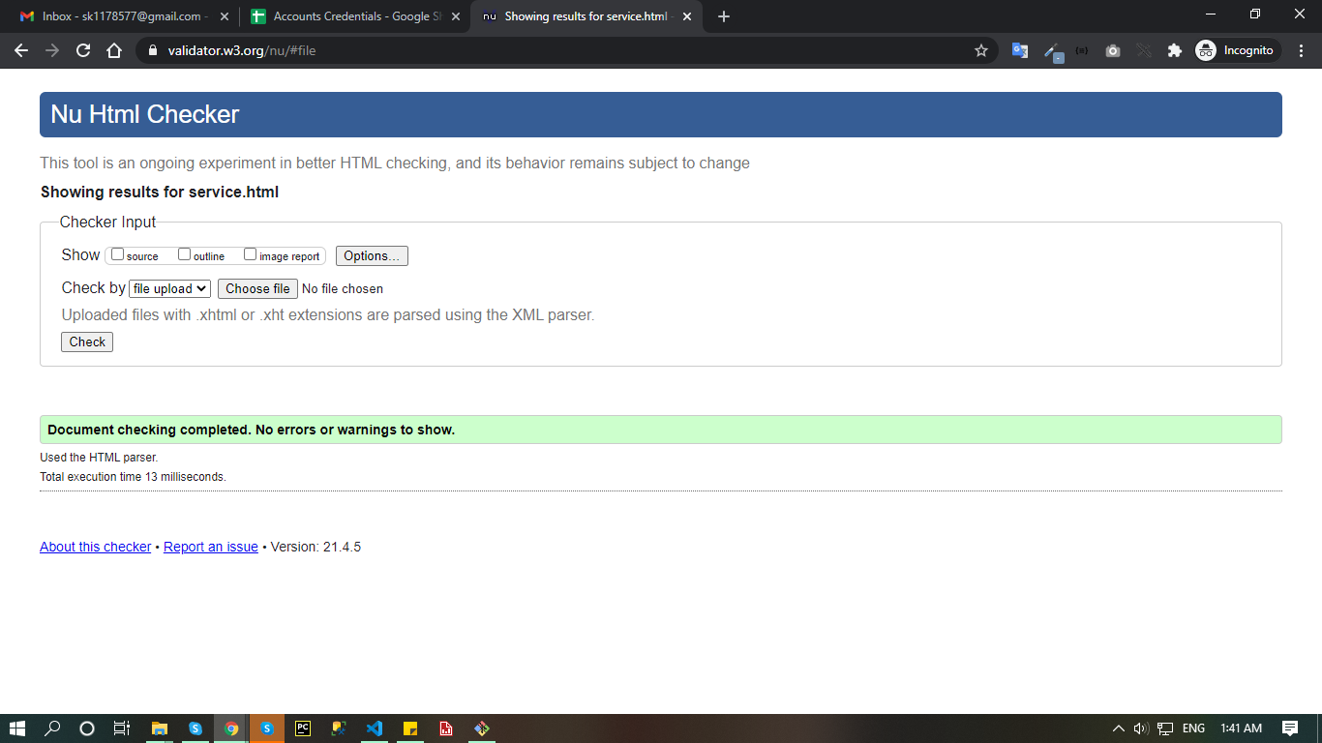

Food categories

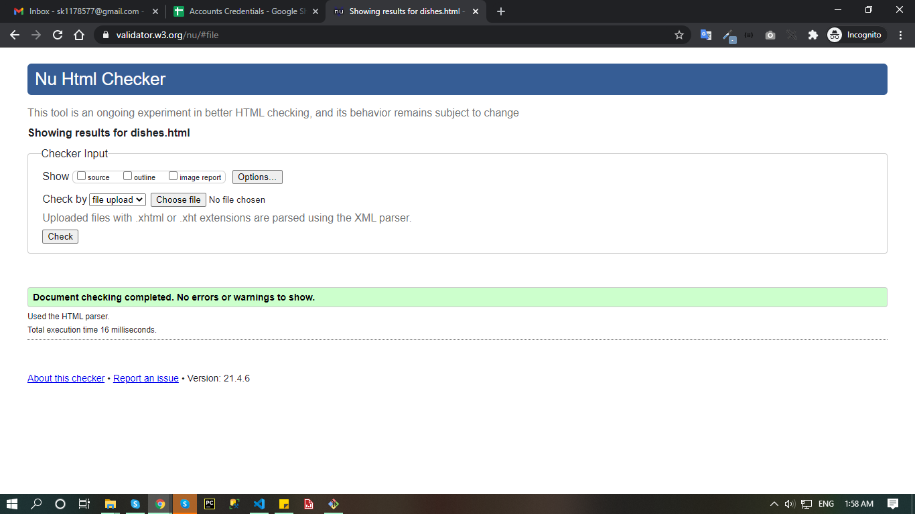

Combo offers

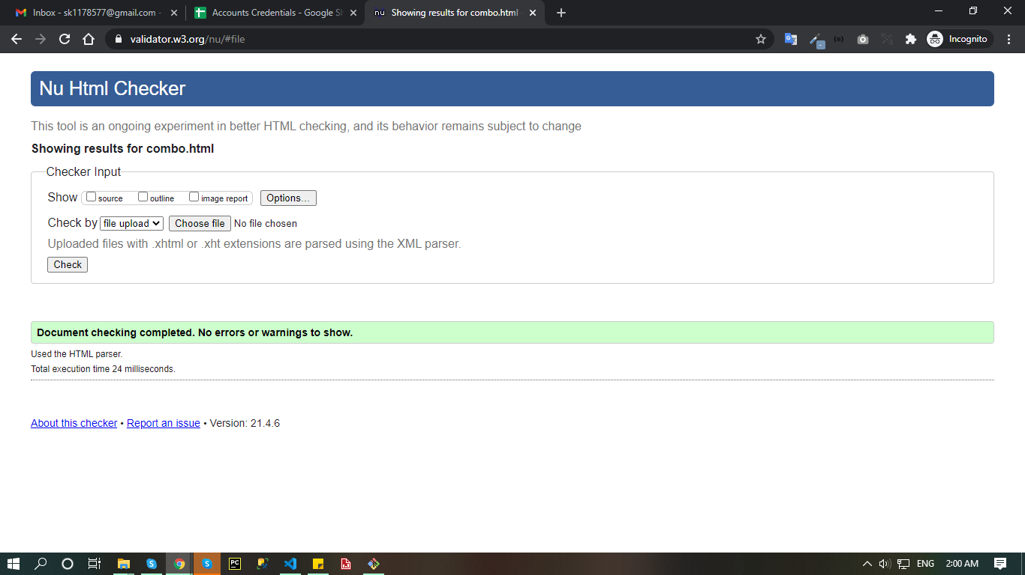

Feedback

